**Instructions for Plotting Transition Density Plot**

1. Ensure the following MATLAB scripts are in the same folder.

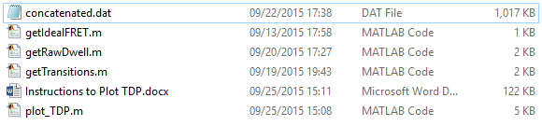

1. Open MATLAB, and navigate to that folder. Alternatively, add that folder to your path by clicking ‘Set Path’ → ‘Add Folder’.
2. Find the path for the concatenated analysis file (.dat) from vbFRET/ebFRET. The concatenated file should have the format “Molecule #”, “Idealized FRET Value”
3. To run the script, enter the script name, followed by an open parenthesis, then the filename of the concatenated file in quotation marks, then a close parenthesis, and then press the ‘Enter’ key. If you want to change any of the customizable arguments discussed below, enter the argument name in quotation marks, then a comma, and then the value for the parameter to take. Additional arguments should be separated by commas, as shown below for ‘fret_min’ and ‘fret_max’.

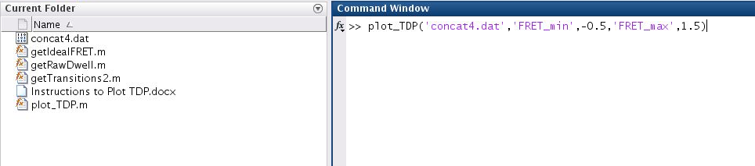

1. A transition density plot will be displayed according to the parameters selected. The number of transitions plotted will also be displayed.

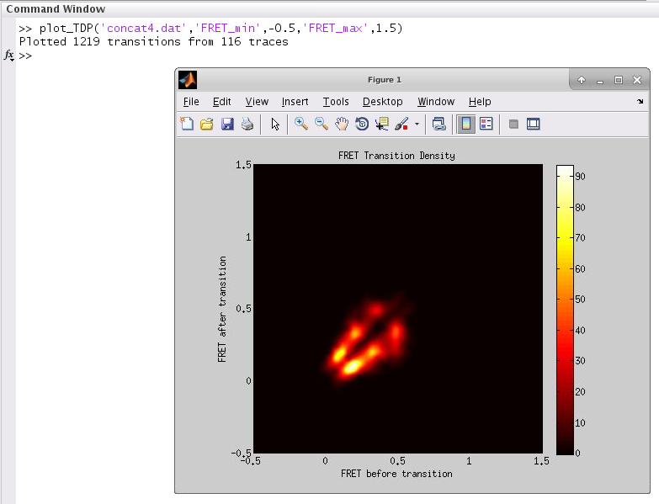

1. The following parameters can be adjusted in the program to suit your needs.

|  |  |  |
| --- | --- | --- |
| **Parameter Name** | **Type** | **Description** |
| bins | Number | Number of bins for FRET data |
| smoothing | True/False | This option when enabled as ‘true’ plots a histogram where the values are smoothed to a Gaussian function. |
| exportdwelldata | True/False | Exports the dwell times as a .dat file when true |
| normbyframes | True/False | Normalizes the intensities of the TDP by the total number of frames. Intensities reflect the number of transitions between FRET X and Y per unit time. |
| normbytransitions | True/False | Normalizes the intensities of the TDP by the total number of transitions. Intensities reflect the fraction of all transitions that occurred between FRET value X and Y. |
| colorlim | [Number Number] | Use these to set the limits on the X and Y axes for the distribution. Generally left as default. |
| fret_min | Number | Set the minimum limit for the X & Y axes in the plot. |
| fret_max | Number | Set the minimum limit for the X & Y axes in the plot. |
| cutofft | Number | When plotting unsmoothed TDPs, this is the maximum number of frames in the traces |
| var | Number | When plotting smoothed TDP’s VAR is the variance of the gaussian used to smooth the TDP the smoothed TDP’s. Thedefault is 0.00075 and need not be changed. |
| resolution | Number | RESOLUTION sets the resolution (number of pixels) of the TDP. The Higher the value, smoother the peak. 800 is optimal |
| discardfirstlast | True/False | Exclude the first and last dwells of each trajectory |
| cmap | String | Name of the Matlab colormap to use: e.g. ‘jet’ |

**Smoothed TDP Unsmoothed TDP**

